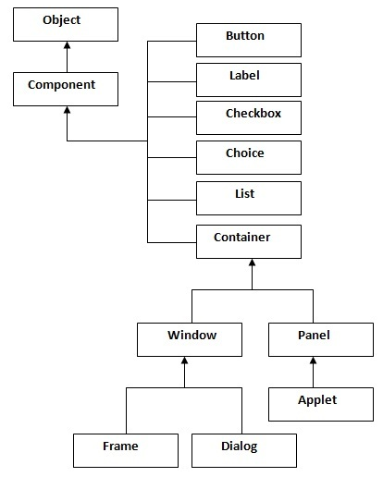

Java AWT Hierarchy

(1) Java AWT Button
import java.awt.*;
public class ButtonExample
{
public static void main(String[] args)
{
Frame f=new Frame("Button Example");
Button b=new Button("Click Here");
b.setBounds(50,100,80,30);
f.add(b);
f.setSize(400,400);
f.setLayout(null);
f.setVisible(true);
}
}
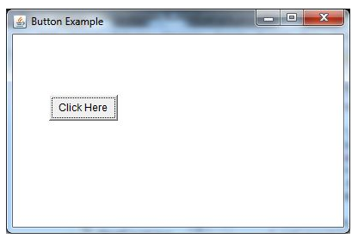

import java.awt.*;
import java.awt.event.*;
public class ButtonExample
{
public static void main(String[] args)
{
Frame f=new Frame("Button Example");
final TextField tf=new TextField();
tf.setBounds(50,50, 150,20);
Button b=new Button("Click Here");
b.setBounds(50,100,60,30);
b.addActionListener(new ActionListener(){
public void actionPerformed(ActionEvent e)
{
tf.setText("Welcome to Javatpoint.");
}
});
f.add(b);f.add(tf);
f.setSize(400,400);
f.setLayout(null);
f.setVisible(true);
}
}
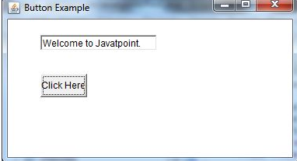

2. Java AWT Label
import java.awt.*;
class LabelExample{
public static void main(String args[])
{
Frame f= new Frame("Label Example");
Label l1,l2;
l1=new Label("First Label.");
l1.setBounds(50,100, 100,30);
l2=new Label("Second Label.");
l2.setBounds(50,150, 100,30);
f.add(l1); f.add(l2);
f.setSize(400,400);
f.setLayout(null);
f.setVisible(true);
}
}
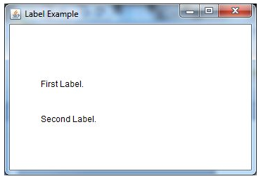

(3) Java AWT TextField
import java.awt.*;
class TextFieldExample{
public static void main(String args[])
{
Frame f= new Frame("TextField Example");
TextField t1,t2;
t1=new TextField("Welcome to Javatpoint.");
t1.setBounds(50,100, 200,30);
t2=new TextField("AWT Tutorial");
t2.setBounds(50,150, 200,30);
f.add(t1); f.add(t2);
f.setSize(400,400);
f.setLayout(null);
f.setVisible(true);
}
}

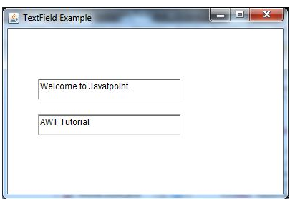

import java.awt.*;
import java.awt.event.*;
public class TextFieldExample extends Frame implements ActionListener
{
TextField tf1,tf2,tf3;
Button b1,b2;
TextFieldExample(){
tf1=new TextField();
tf1.setBounds(50,50,150,20);
tf2=new TextField();
tf2.setBounds(50,100,150,20);
tf3=new TextField();
tf3.setBounds(50,150,150,20);
tf3.setEditable(false);
b1=new Button("+");
b1.setBounds(50,200,50,50);
b2=new Button("-");
b2.setBounds(120,200,50,50);
b1.addActionListener(this);
b2.addActionListener(this);
add(tf1);add(tf2);add(tf3);add(b1);add(b2);
setSize(300,300);
setLayout(null);
setVisible(true);
}
public void actionPerformed(ActionEvent e) {
String s1=tf1.getText();
String s2=tf2.getText();
int a=Integer.parseInt(s1);
int b=Integer.parseInt(s2);
int c=0;
if(e.getSource()==b1){
c=a+b;
}else if(e.getSource()==b2){
c=a-b;
}
String result=String.valueOf(c);
tf3.setText(result);
}
public static void main(String[] args) {
new TextFieldExample();
}
}

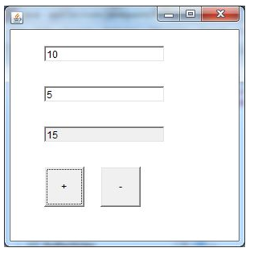

(4) Java AWT TextArea
import java.awt.*;
public class TextAreaExample
{
TextAreaExample(){
Frame f= new Frame();
TextArea area=new TextArea("Welcome to javatpoint");
area.setBounds(10,30, 300,300);
f.add(area);
f.setSize(400,400);
f.setLayout(null);
f.setVisible(true);
}
public static void main(String args[])
{
new TextAreaExample();
}
}
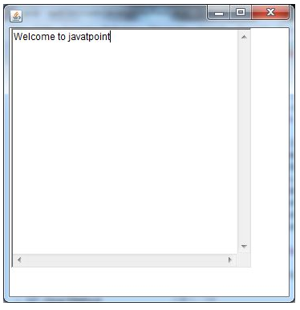
import java.awt.*;
import java.awt.event.*;
public class TextAreaExample extends Frame implements ActionListener{
Label l1,l2;
TextArea area;
Button b;
TextAreaExample(){
l1=new Label();
l1.setBounds(50,50,100,30);
l2=new Label();
l2.setBounds(160,50,100,30);
area=new TextArea();
area.setBounds(20,100,300,300);
b=new Button("Count Words");
b.setBounds(100,400,100,30);
b.addActionListener(this);
add(l1);add(l2);add(area);add(b);
setSize(400,450);
setLayout(null);
setVisible(true);
}
public void actionPerformed(ActionEvent e){
String text=area.getText();
String words[]=text.split("\\s");
l1.setText("Words: "+words.length);

l2.setText("Characters: "+text.length());
}
public static void main(String[] args) {
new TextAreaExample();
}
}
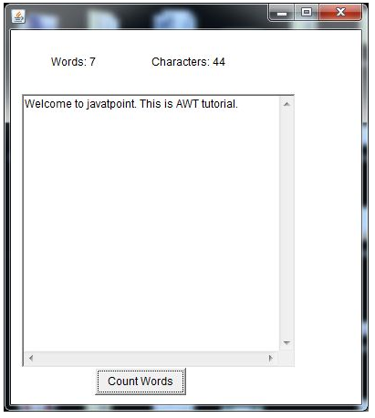

(5) Java AWT Checkbox
import java.awt.*;
public class CheckboxExample
{
CheckboxExample(){
Frame f= new Frame("Checkbox Example");
Checkbox checkbox1 = new Checkbox("C++");
checkbox1.setBounds(100,100, 50,50);
Checkbox checkbox2 = new Checkbox("Java", true);
checkbox2.setBounds(100,150, 50,50);
f.add(checkbox1);
f.add(checkbox2);
f.setSize(400,400);
f.setLayout(null);
f.setVisible(true);
}
public static void main(String args[])
{
new CheckboxExample();
}
}
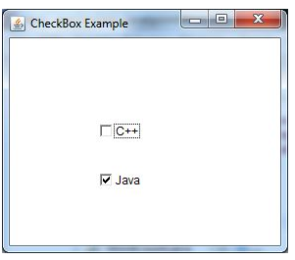
import java.awt.*;
import java.awt.event.*;
public class CheckboxExample
{
CheckboxExample(){
Frame f= new Frame("CheckBox Example");
final Label label = new Label();
label.setAlignment(Label.CENTER);
label.setSize(400,100);
Checkbox checkbox1 = new Checkbox("C++");
checkbox1.setBounds(100,100, 50,50);
Checkbox checkbox2 = new Checkbox("Java");
checkbox2.setBounds(100,150, 50,50);
f.add(checkbox1); f.add(checkbox2); f.add(label);
checkbox1.addItemListener(new ItemListener() {
public void itemStateChanged(ItemEvent e) {
label.setText("C++ Checkbox: "
+ (e.getStateChange()==1?"checked":"unchecked"));
}
});
checkbox2.addItemListener(new ItemListener() {
public void itemStateChanged(ItemEvent e) {
label.setText("Java Checkbox: "
+ (e.getStateChange()==1?"checked":"unchecked"));
}
});
f.setSize(400,400);
f.setLayout(null);
f.setVisible(true);
}
public static void main(String args[])
{
new CheckboxExample();
}
}

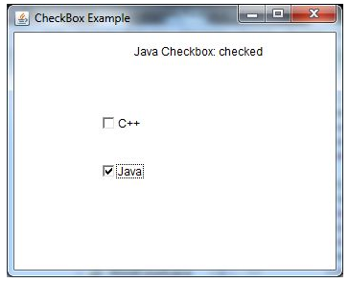

(6) Java AWT CheckboxGroup
import java.awt.*;
public class CheckboxGroupExample
{
CheckboxGroupExample(){
Frame f= new Frame("CheckboxGroup Example");
CheckboxGroup cbg = new CheckboxGroup();
Checkbox checkBox1 = new Checkbox("C++", cbg, false);
checkBox1.setBounds(100,100, 50,50);
Checkbox checkBox2 = new Checkbox("Java", cbg, true);
checkBox2.setBounds(100,150, 50,50);
f.add(checkBox1);
f.add(checkBox2);
f.setSize(400,400);
f.setLayout(null);
f.setVisible(true);
}
public static void main(String args[])
{
new CheckboxGroupExample();
}
}

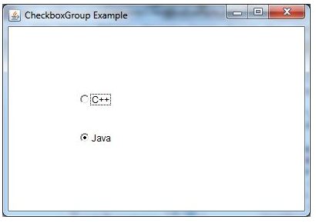
import java.awt.*;
import java.awt.event.*;
public class CheckboxGroupExample
{
CheckboxGroupExample(){
Frame f= new Frame("CheckboxGroup Example");
final Label label = new Label();
label.setAlignment(Label.CENTER);
label.setSize(400,100);
CheckboxGroup cbg = new CheckboxGroup();
Checkbox checkBox1 = new Checkbox("C++", cbg, false);
checkBox1.setBounds(100,100, 50,50);
Checkbox checkBox2 = new Checkbox("Java", cbg, false);
checkBox2.setBounds(100,150, 50,50);
f.add(checkBox1); f.add(checkBox2); f.add(label);
f.setSize(400,400);
f.setLayout(null);
f.setVisible(true);
checkBox1.addItemListener(new ItemListener() {
public void itemStateChanged(ItemEvent e) {
label.setText("C++ checkbox: Checked");
}
});
checkBox2.addItemListener(new ItemListener() {
public void itemStateChanged(ItemEvent e) {
label.setText("Java checkbox: Checked");
}
});
}
public static void main(String args[])
{
new CheckboxGroupExample();
}
}

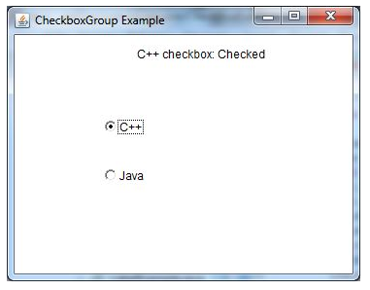

(7) Java AWT Choice
import java.awt.*;
public class ChoiceExample
{
ChoiceExample(){
Frame f= new Frame();
Choice c=new Choice();
c.setBounds(100,100, 75,75);
c.add("Item 1");
c.add("Item 2");
c.add("Item 3");
c.add("Item 4");
c.add("Item 5");
f.add(c);
f.setSize(400,400);
f.setLayout(null);
f.setVisible(true);
}
public static void main(String args[])
{
new ChoiceExample();
}
}
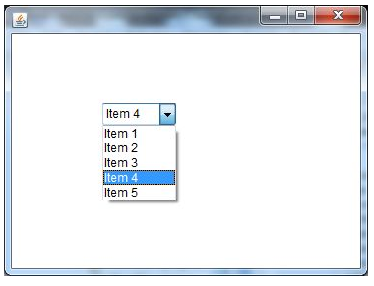
import java.awt.*;
import java.awt.event.*;
public class ChoiceExample
{
ChoiceExample(){
Frame f= new Frame();
final Label label = new Label();
label.setAlignment(Label.CENTER);
label.setSize(400,100);
Button b=new Button("Show");
b.setBounds(200,100,50,20);
final Choice c=new Choice();
c.setBounds(100,100, 75,75);
c.add("C");
c.add("C++");
c.add("Java");
c.add("PHP");
c.add("Android");
f.add(c);f.add(label); f.add(b);
f.setSize(400,400);
f.setLayout(null);
f.setVisible(true);
b.addActionListener(new ActionListener() {
public void actionPerformed(ActionEvent e) {
String data = "Programming language Selected: "+ c.getItem(c.getSelectedIndex());
label.setText(data);
}
});
}
public static void main(String args[])
{
new ChoiceExample();
}
}
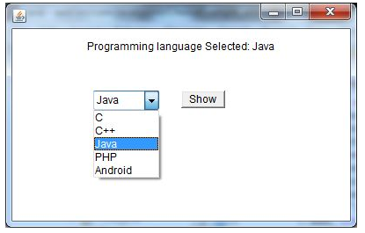

(8) Java AWT List
- import java.awt.*;
- public class ListExample
- {
- ListExample(){
- Frame f= new Frame();
- List l1=new List(5);
- l1.setBounds(100,100, 75,75);
- l1.add("Item 1");
- l1.add("Item 2");
- l1.add("Item 3");
- l1.add("Item 4");
- l1.add("Item 5");
- f.add(l1);
- f.setSize(400,400);
- f.setLayout(null);
- f.setVisible(true);
- }
- public static void main(String args[])
- {
- new ListExample();
- }
- }
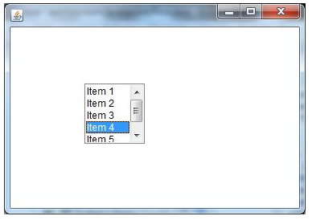
- import java.awt.*;
- import java.awt.event.*;
- public class ListExample
- {
- ListExample(){
- Frame f= new Frame();
- final Label label = new Label();
- label.setAlignment(Label.CENTER);
- label.setSize(500,100);
- Button b=new Button("Show");
- b.setBounds(200,150,80,30);
- final List l1=new List(4, false);
- l1.setBounds(100,100, 70,70);
- l1.add("C");
- l1.add("C++");
- l1.add("Java");
- l1.add("PHP");
- final List l2=new List(4, true);
- l2.setBounds(100,200, 70,70);
- l2.add("Turbo C++");
- l2.add("Spring");
- l2.add("Hibernate");
- l2.add("CodeIgniter");
- f.add(l1); f.add(l2); f.add(label); f.add(b);
- f.setSize(450,450);
- f.setLayout(null);
- f.setVisible(true);
- b.addActionListener(new ActionListener() {
- public void actionPerformed(ActionEvent e) {
- String data = "Programming language Selected: "+l1.getItem(l1.getSelectedIndex());
- data += ", Framework Selected:";
- for(String frame:l2.getSelectedItems()){
- data += frame + " ";
- }
- label.setText(data);
- }
- });
- }
- public static void main(String args[])
- {
- new ListExample();
- }
- }
